Project Documentation

Crime Incidents in 2025

1.Project Overview
This project analyses crime incident data for the year 2025 using Excel, Power Query and Power BI to identify patterns, trends and high-risk areas. The analysis focuses on understanding crime distribution across wards and neighborhood clusters, identifying frequently occurring crime types, and examining time-based patterns. The objective of this project is to transform raw crime data into meaningful insights through interactive dashboards and visual reports. The dashboard enables data-driven insights that can support decision making in public safety and urban management.

2.Tools used
- Microsoft Excel
- Power Query
- Power BI Desktop

3.Dataset
- Source: Crime_Incidents_in_2025.csv
- Data contains:
- Incident ID
- Report Date, Report Time
- Start Date, Start Time
- End Date, End Time
- Street Block
- Offense
- Method
- Shift
- Ward
- District
- Latitude & Longitude
- XBLOCK, YBLOCK
- Object ID

4.Steps followed
- Cleaned the data in Excel
- Removed duplicate records
- Handled missing / null values
- Standardized column names
- Corrected data types
- Converted date columns to proper date format
- Split date and time Columns
- Removed unnecessary columns.
- Imported cleaned data into Power BI
- Created DAX measures in Power BI
- Built dashboard using charts, slicers, map, tables and KPIs

5.Key Visualizations
- KPI Cards (Total incidents, Total wards, Total offense types, Overall crime KPI)
- Slicers (Ward, District, Shift, Offense)
- Column Chart (Ward wise comparison)
- Bar Chart (Offense distribution)
- Line Chart (Monthly crime trend)
- Donut Chart (Shift distribution)
- Funnel Chart (Incident distribution by neighborhood cluster)
- Map (Geographic crime distribution)
- Matrix (Crime trend by month & shift)
- Decomposition Tree (Incident pattern across wards & methods)
- Table (Ward wise summary)
- Drill-through for Ward Details

6.Key Insights
- A significant number of crime incidents were recorded in 2025, indicating the need for continuous monitoring and preventive measures.
- Certain wards especially ward 2 reported a higher concentration of incidents compared to others, highlighting location -based risk patterns.
- Theft/other contributed the highest share of total incidents, indicating dominant crime trends.
- Crime incidents showed noticeable variation across months, with certain months like April recording peak activity.
- Some neighborhood clusters like Cluster 6 consistently recorded higher incidents, suggesting area-specific safety concerns.
- Certain time periods(morning/evening/night) showed higher crime occurrence, helping identify high-risk hours.
- Map visualization revealed concentrated hotspots where crime occurrences were significantly higher.

7.Screenshots

Figure 1: Crime Incident Intelligence Dashboard Overview
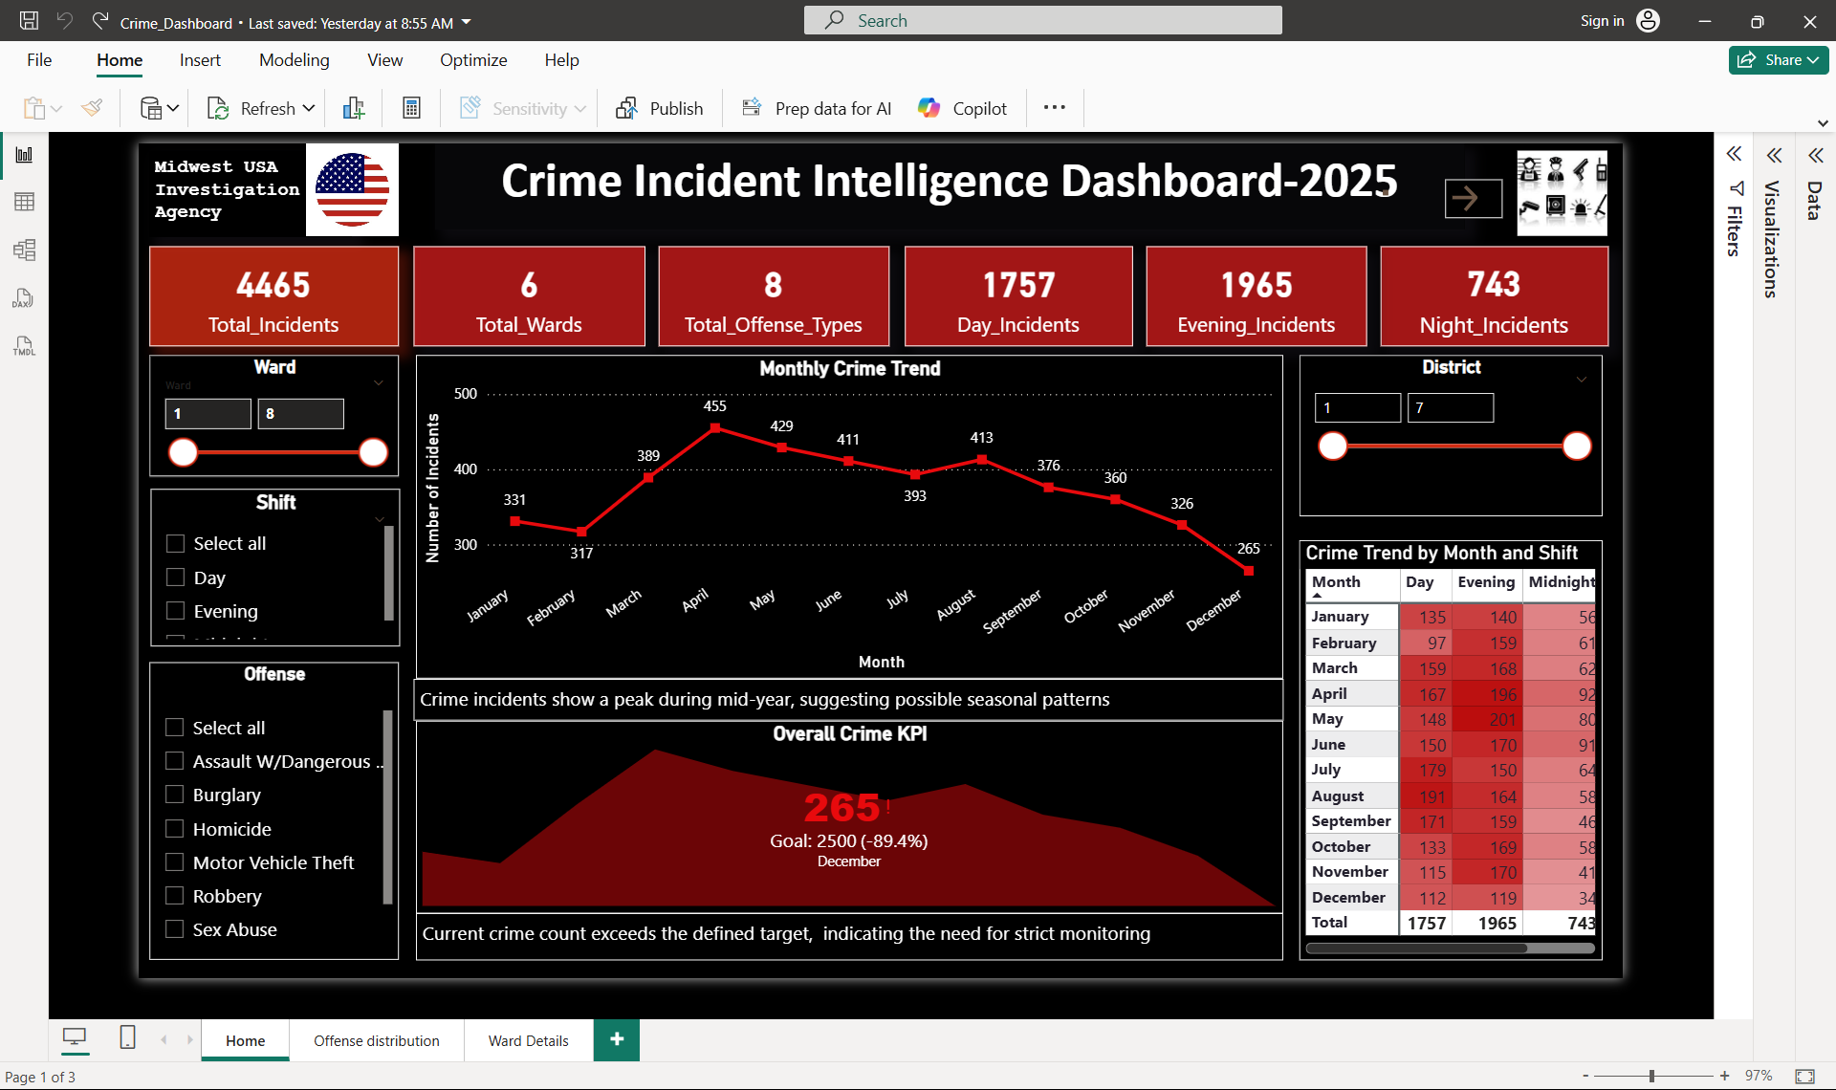

Figure 2: Offense Distribution and Map Visualization

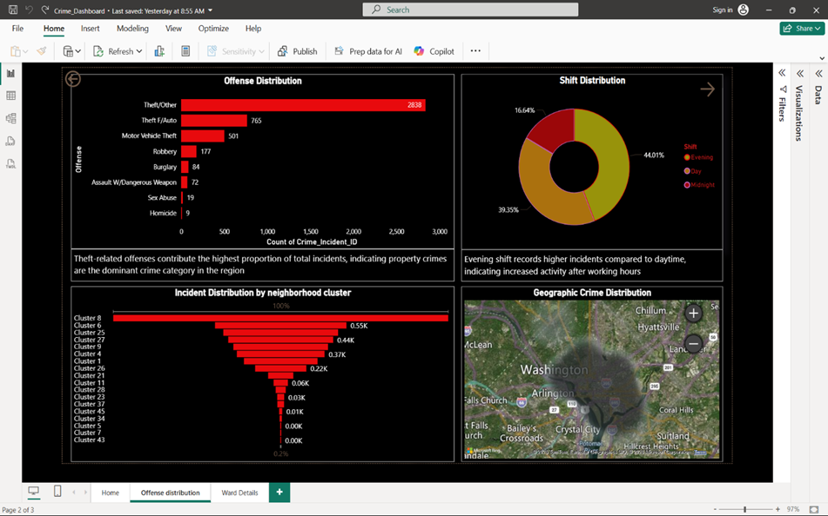
Figure 3: Ward-wise Crime Comparison
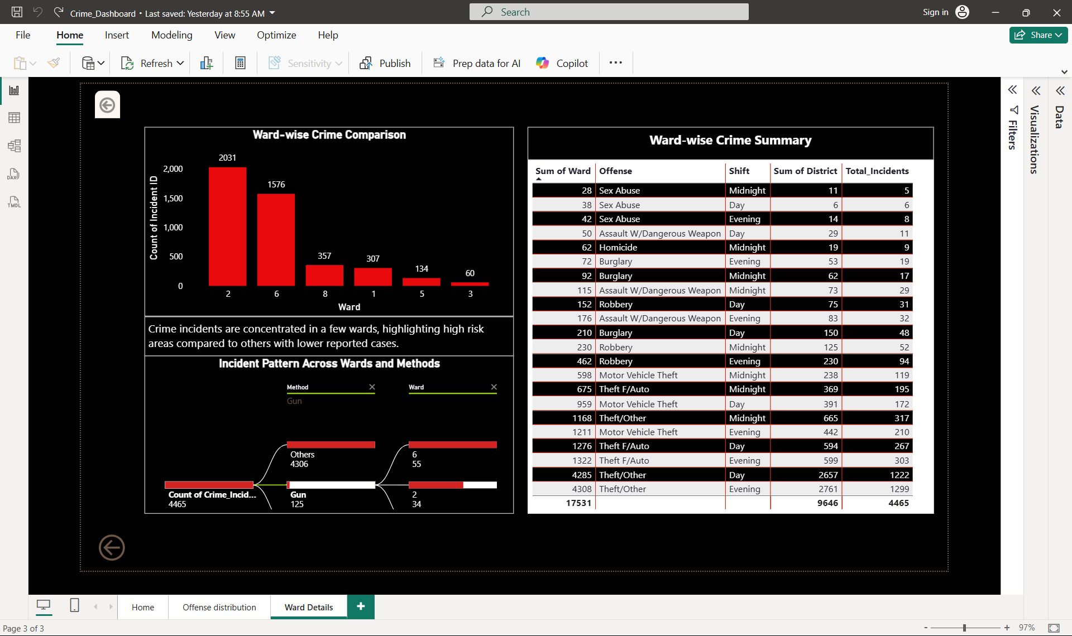

8.Files Included
The following files are attached:
- Crime_Incidents_in_2025_data.xlsx- Cleaned dataset
- Crime_Incidents_in_2025_Report.pbix- Power BI Dashboard file
- README.docx- Project documentation

9.How to Use
- Open the Excel file to view the cleaned dataset.
- Open the .pbix file using Power BI Desktop to explore the interactive dashboard.
- Use slicers to filter data by Ward, District, Offense or Shift.
- Interact with charts to explore dynamic insights.

10.Conclusion
This project demonstrates how raw crime data can be converted into meaningful insights using Power BI. Through data cleaning, dynamic calculation using DAX and interactive dashboard creation, various crime patterns were identified based on ward, offense type, shift and location.
The dashboard enables effective monitoring of crime trends and supports data-driven decision-making for improved safety planning and resource allocation.

